Challenge: How To Add CSS
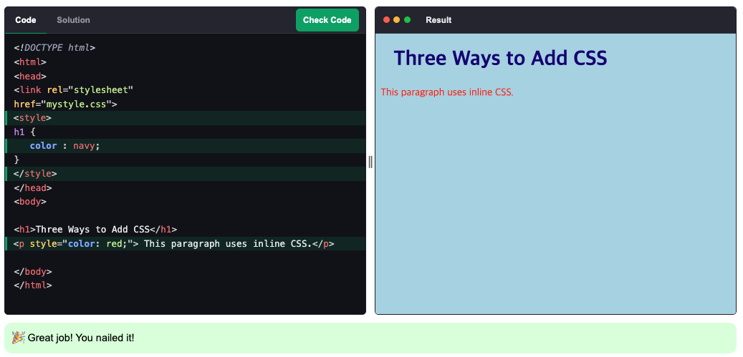

Challenge: Group Headings and Paragraphs
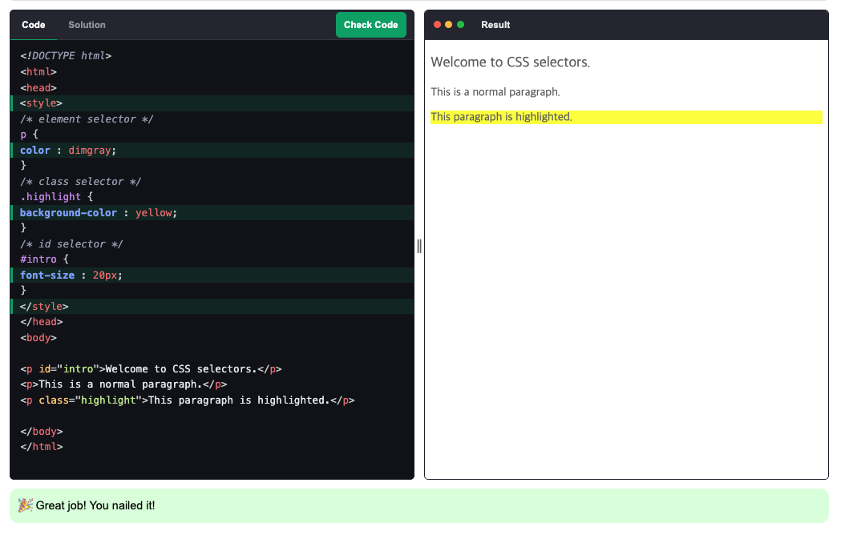

Challenge: Pseudo-classes
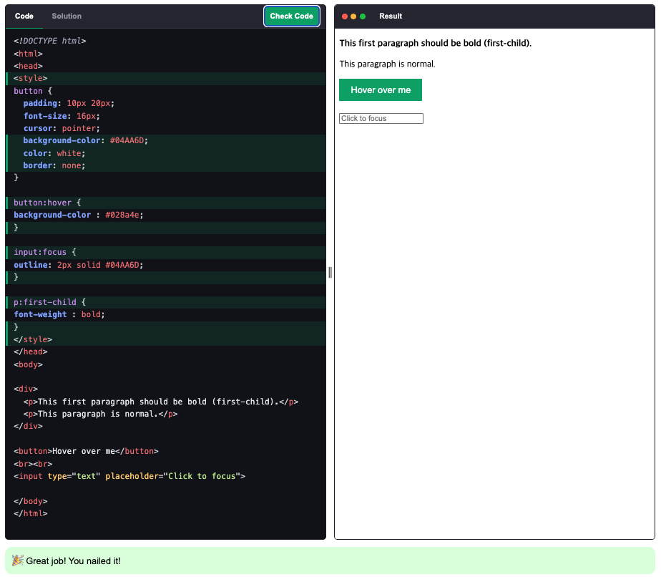

Challenge: Colors
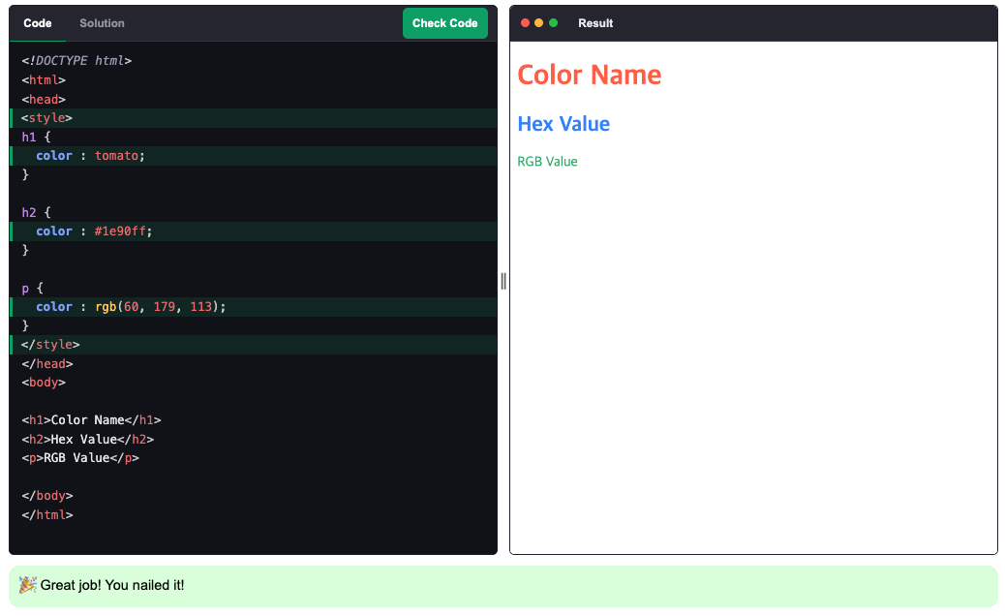

Challenge: Fonts
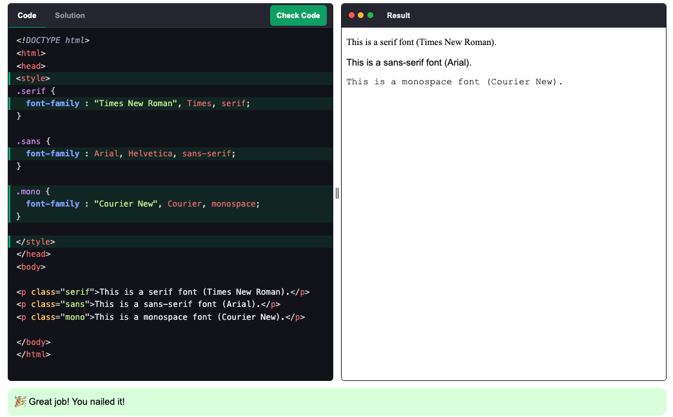

Challenge: Text
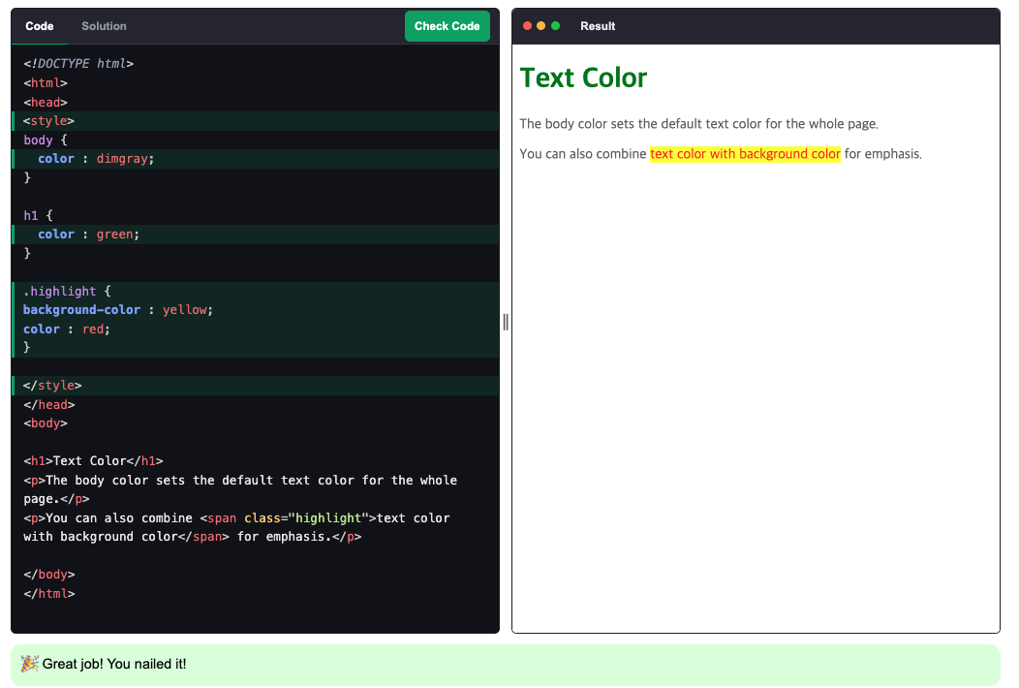

Challenge: Backgrounds
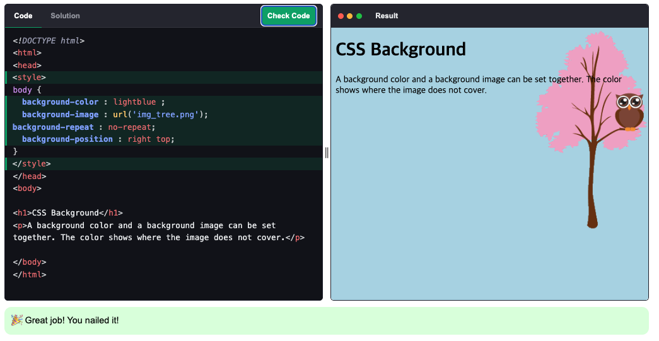

Challenge: Position
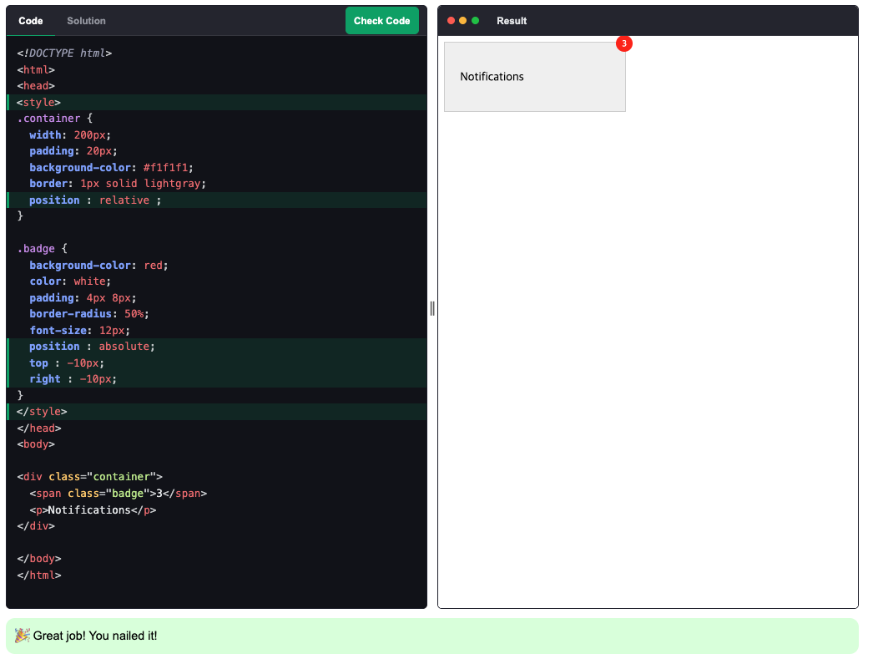

Challenge: Inheritance
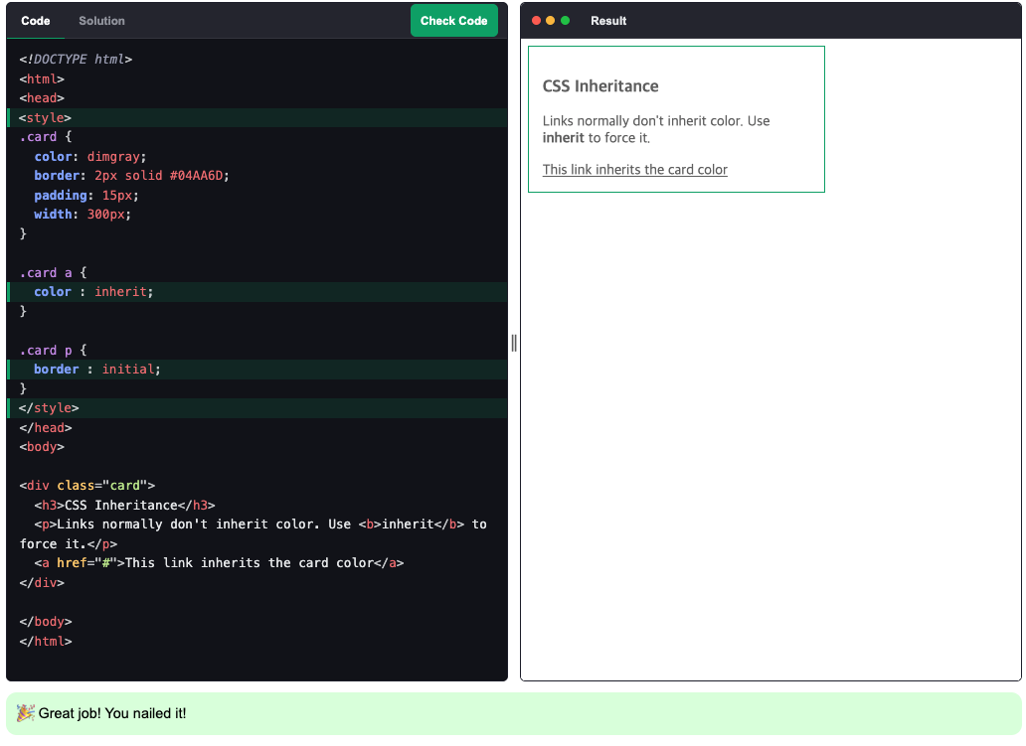

—----------------------------------------

Challenge: Float
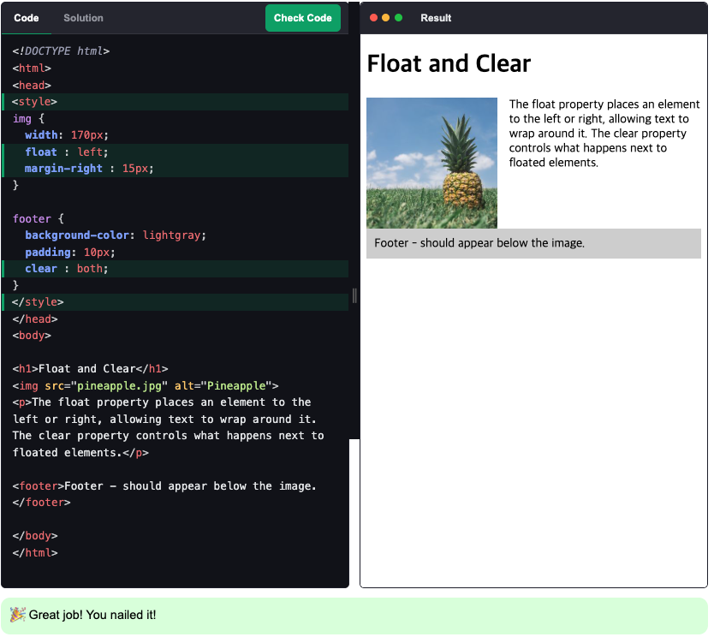

Challenge: Inline-block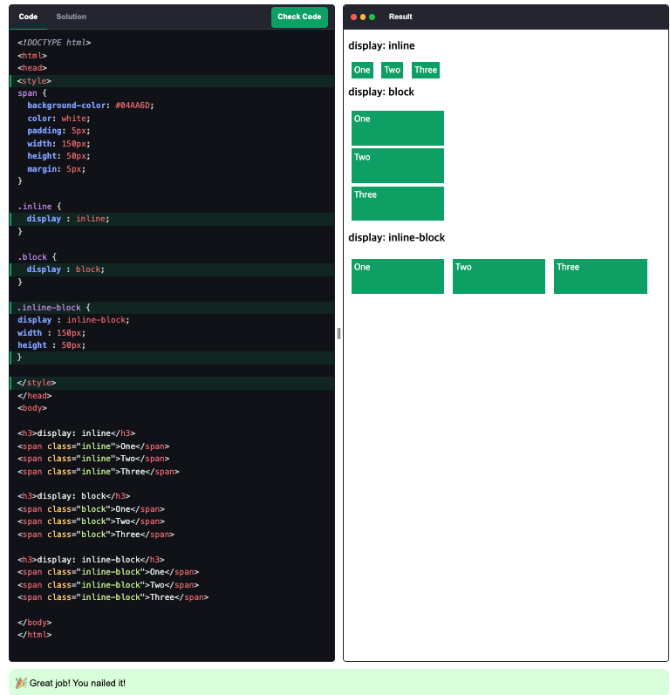

Challenge: Flexbox Intro
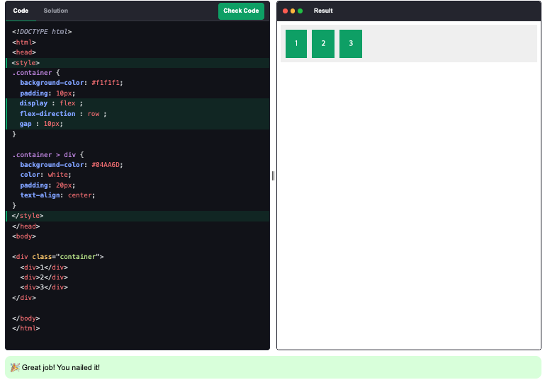

Challenge: Flex Container
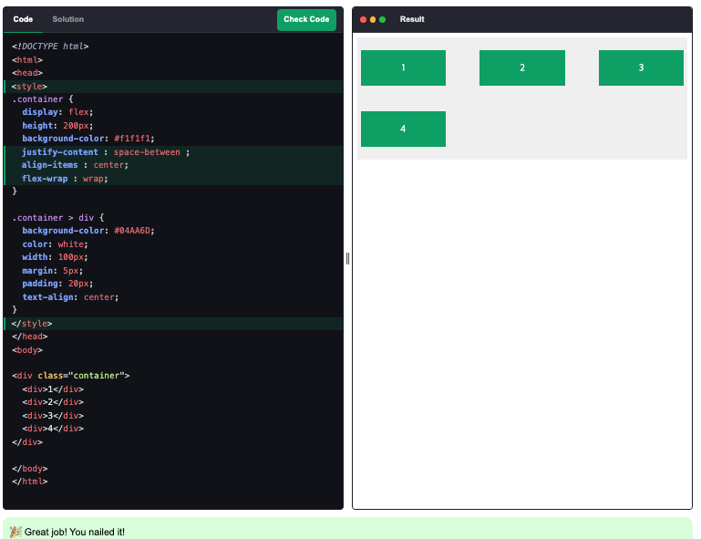
Flexbox Items - https://www.w3schools.com/css/css3_flexbox_items.asp

Challenge: CSS Grid Intro
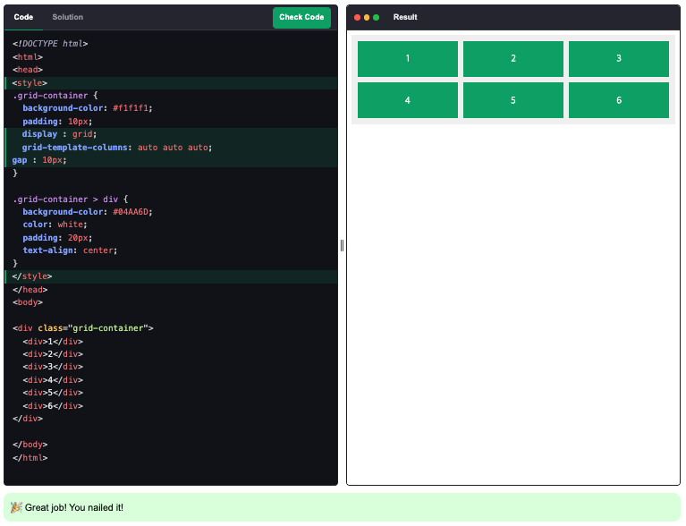

Challenge: Grid Container
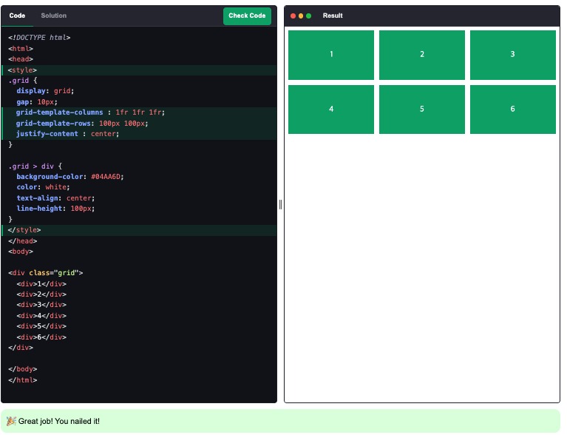

Challenge: Grid Items
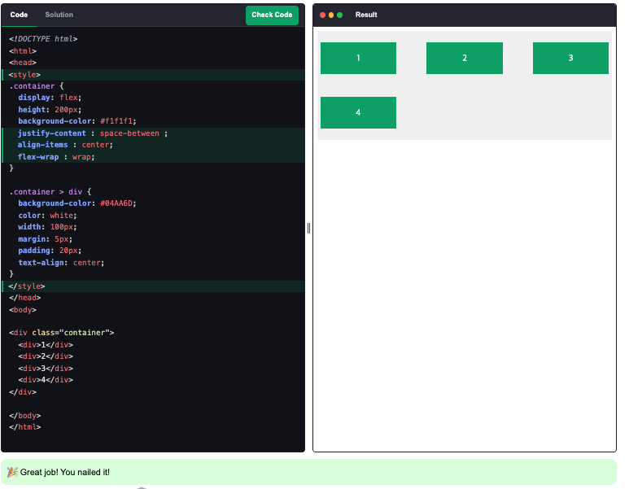
—------------------------------------------------------------------------------------------------------------------------

Challenge: CSS Transforms

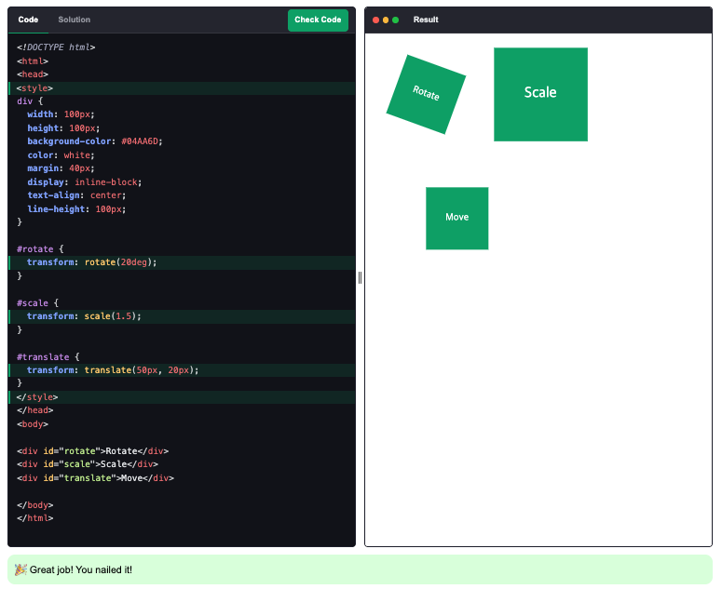

Challenge: CSS 3D Transforms

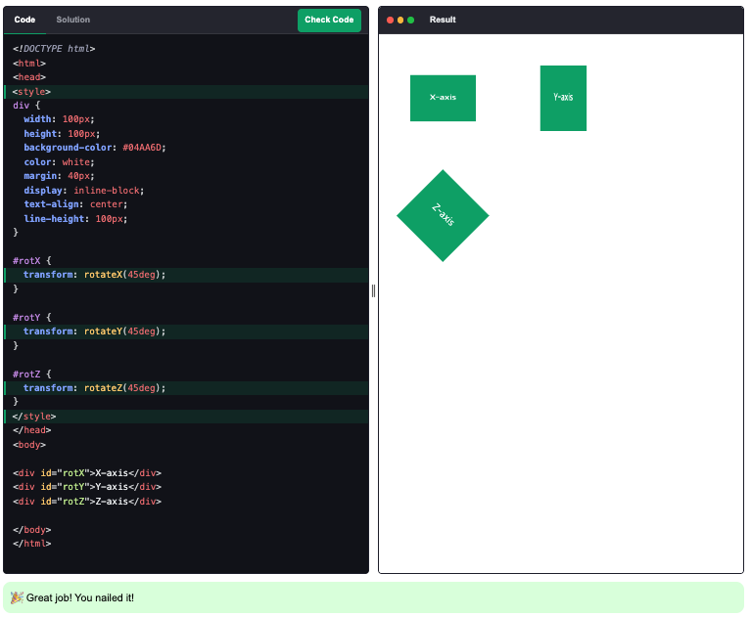

Challenge: CSS Transitions

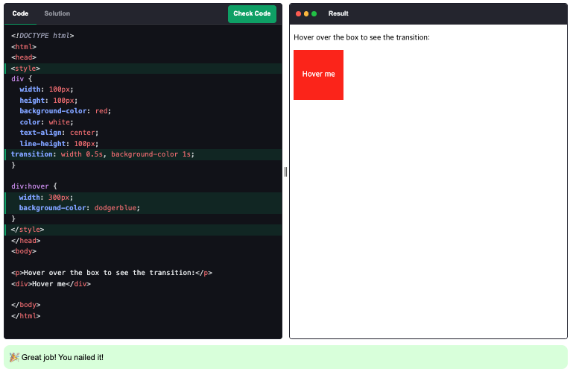

Challenge: CSS Animations

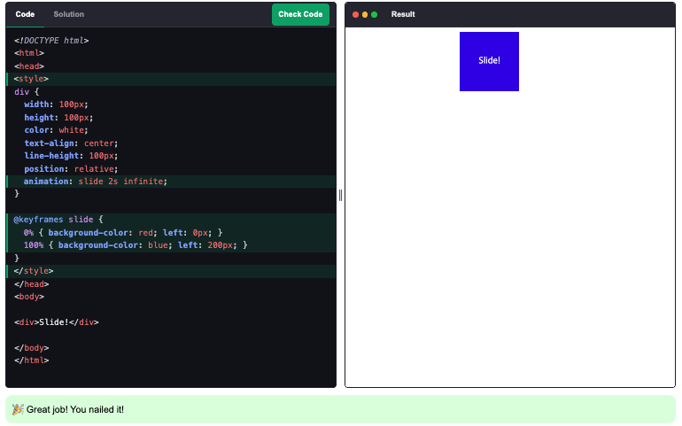

Challenge: Responsive Web Design Intro

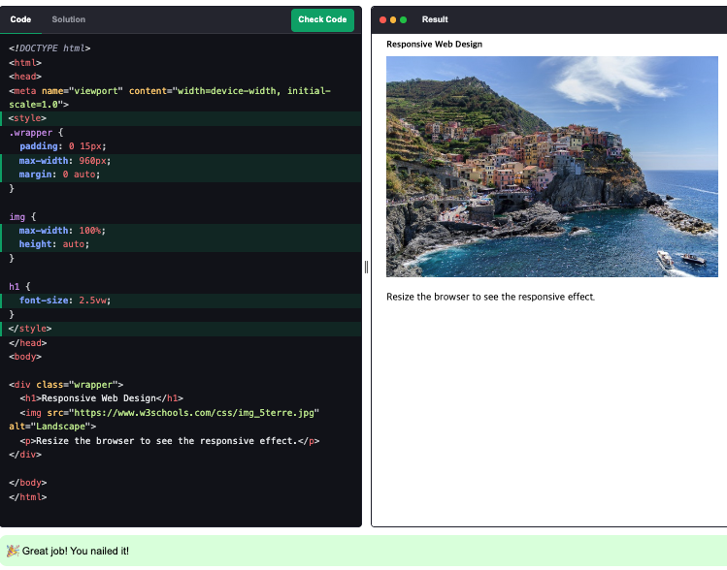

Challenge: Viewport

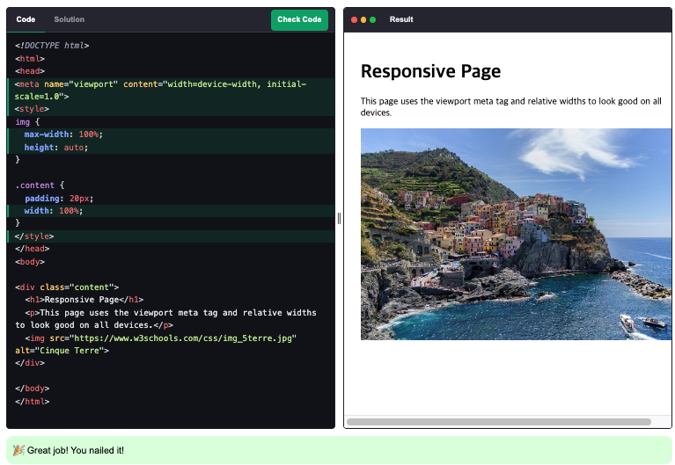

Challenge: RWD Grid View

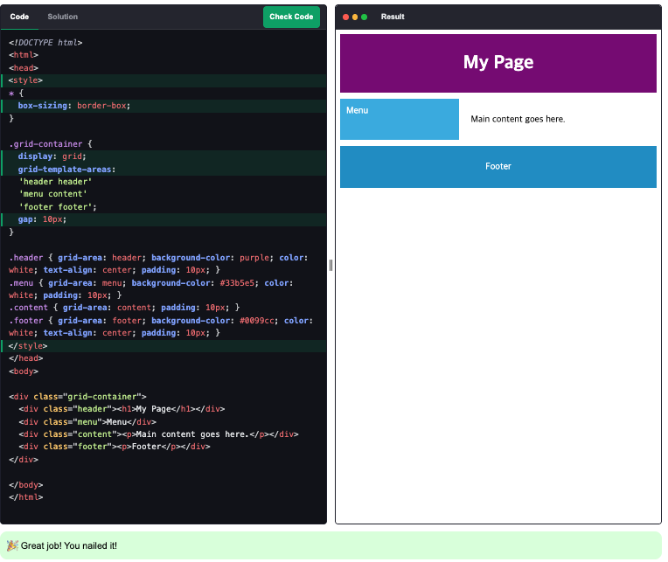

Challenge: RWD Grid View <–링크오류



Challenge: Variables

